Cambridge Historical Society Inc

Agenda

Annual General Meeting
Cambridge Bridge Clubrooms
Fort Street, Cambridge
Thursday 16 November 2023 at 7.30pm

Apologies

Remembering past members

Minutes of 2022 AGM

Matters arising

President’s report

Treasurers report

Election of Officers and appointment of Auditor

Subscriptions for 2024

General Business

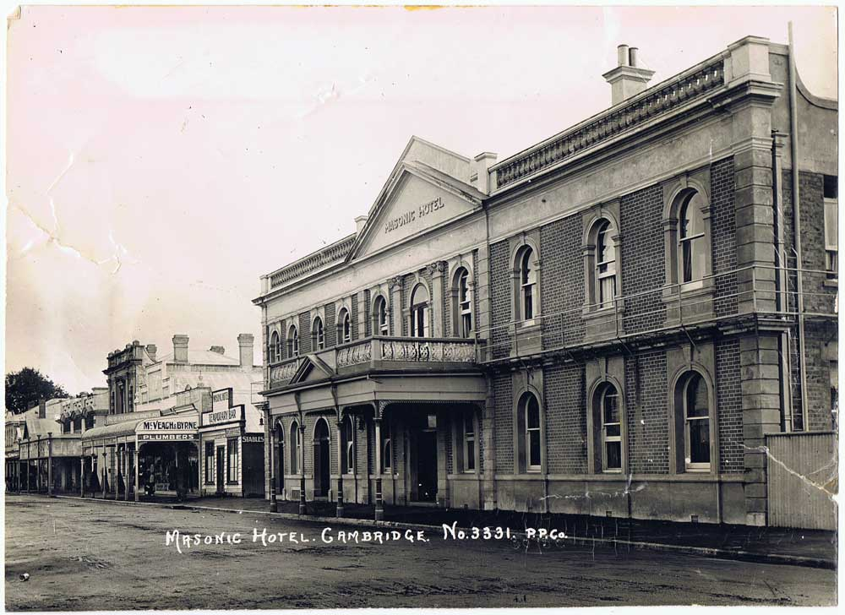
Following the meeting, we are delighted to have Gerry Westenburg as our Guest Speaker.

Gerry is in the process of transforming the Masonic Hotel into a high-end five star boutique hotel with 29 guest rooms including 12 attic rooms, a restaurant, café, terraced gardens, a basement speakeasy bar and conference and function rooms.
He will take us through the building’s history, and update us with his progress on its restoration.

