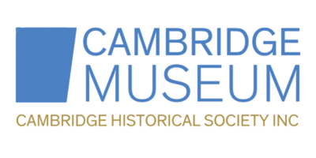

Committee Member: Role Description
About Us
Cambridge Historical Society is a volunteer-led charity dedicated to caring, protecting and sharing the history and heritage of our local area. We operate Cambridge Museum, care for a growing collection, and host events, exhibitions, and education programmes for the community.

Purpose of the Role
As a Committee Member, you will contribute to the strategic direction, sustainability, and effective governance of our charity. You will work collaboratively with fellow members to support our staff and volunteers, and to ensure we meet our charitable objectives and legal responsibilities.

Key Responsibilities
- Attend monthly Committee Meetings
- Contribute to Strategic Planning – help shape the organisation’s goals and future direction
- Support Financial Oversight – approve budgets, monitor spending, and support fundraising (financial skills especially welcomed)
- Oversee Museum Operations – support the governance of our museum and its programmes
- Ensure Compliance – uphold the organisation’s constitution, policies, and legal obligations
- Champion Our Work – act as an ambassador in the community and support public engagement

Skills and Experience We Welcome
We are particularly interested in members with experience in one or more of the following:
- Finance or accounting
- Event planning or community engagement
- Grant writing or fundraising
- Marketing, media, or communications
- Board or governance experience
- Knowledge or passion for history and heritage

Commitment
- Approx. 2–5 hours per month
- Attendance at monthly meetings (in person or online)
- Additional time for subcommittees, event support, or special projects, if desired

Term
An initial term of one year, renewable

Support and Induction
New members receive an induction to our organisation, history, and governance. You will be supported by an experienced team and can choose to take on a general role or focus on a particular area of interest.

Why Join?
- Make a meaningful difference in your community
- Support the preservation of local stories, places, and taonga
- Gain governance experience and develop new skills
- Meet like-minded people with a passion for heritage

